**Phase V: Table Implementation and Data Insertion** for your **Movies Management System**.

## ****Objective****

To convert the logical model into a physical Oracle database structure by creating tables, applying constraints, and inserting realistic sample data.  
  
TABLES CREATION

-- MOVIE Table

CREATE TABLE movie (

movie_id NUMBER GENERATED BY DEFAULT AS IDENTITY PRIMARY KEY,

title VARCHAR2(100) NOT NULL,

genre VARCHAR2(50),

duration NUMBER(3), -- in minutes

language VARCHAR2(30),

rating VARCHAR2(10)

);

-- THEATER Table

CREATE TABLE theater (

theater_id NUMBER GENERATED BY DEFAULT AS IDENTITY PRIMARY KEY,

name VARCHAR2(100) NOT NULL,

location VARCHAR2(100),

total_seats NUMBER NOT NULL CHECK (total_seats > 0)

);

-- SHOW Table

CREATE TABLE showtime (

show_id NUMBER GENERATED BY DEFAULT AS IDENTITY PRIMARY KEY,

movie_id NUMBER REFERENCES movie(movie_id),

theater_id NUMBER REFERENCES theater(theater_id),

show_time TIMESTAMP NOT NULL

);

-- CUSTOMER Table

CREATE TABLE customer (

customer_id NUMBER GENERATED BY DEFAULT AS IDENTITY PRIMARY KEY,

full_name VARCHAR2(100) NOT NULL,

email VARCHAR2(100) UNIQUE,

phone VARCHAR2(15)

);

-- TICKET Table

CREATE TABLE ticket (

ticket_id NUMBER GENERATED BY DEFAULT AS IDENTITY PRIMARY KEY,

show_id NUMBER REFERENCES showtime(show_id),

customer_id NUMBER REFERENCES customer(customer_id),

seat_number VARCHAR2(10) NOT NULL,

price NUMBER(6,2) NOT NULL CHECK (price > 0),

UNIQUE (show_id, seat_number) -- Prevent double booking

);

-- PAYMENT Table

CREATE TABLE payment (

payment_id NUMBER GENERATED BY DEFAULT AS IDENTITY PRIMARY KEY,

ticket_id NUMBER REFERENCES ticket(ticket_id),

amount NUMBER(6,2) NOT NULL,

payment_method VARCHAR2(20) DEFAULT 'cash',

payment_date TIMESTAMP DEFAULT CURRENT_TIMESTAMP

);

-- STAFF Table

CREATE TABLE staff (

staff_id NUMBER GENERATED BY DEFAULT AS IDENTITY PRIMARY KEY,

name VARCHAR2(100) NOT NULL,

role VARCHAR2(30),

username VARCHAR2(50) UNIQUE NOT NULL,

password VARCHAR2(100) NOT NULL

);  
  
  
TABLE CREATED SUCCESSFULLY SCREENSHOTS  
  
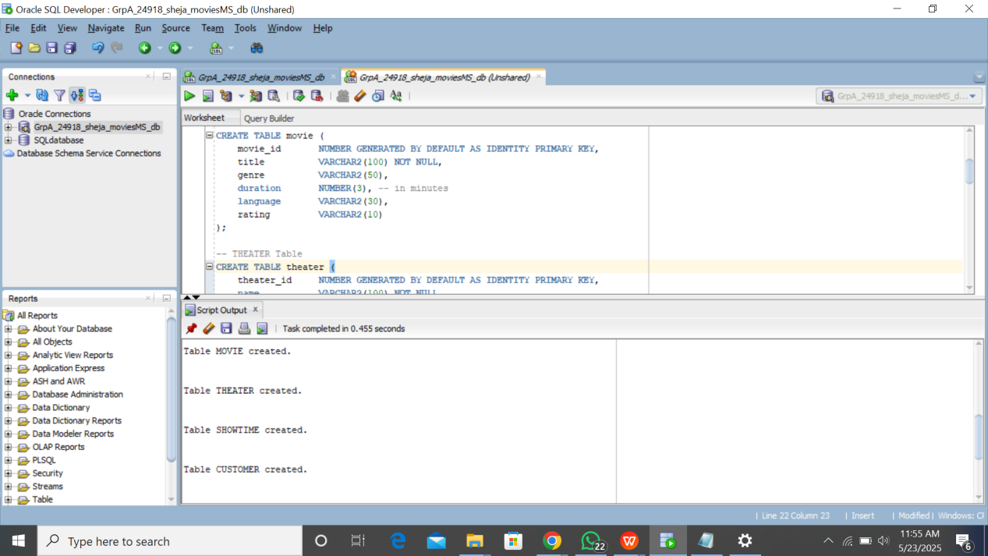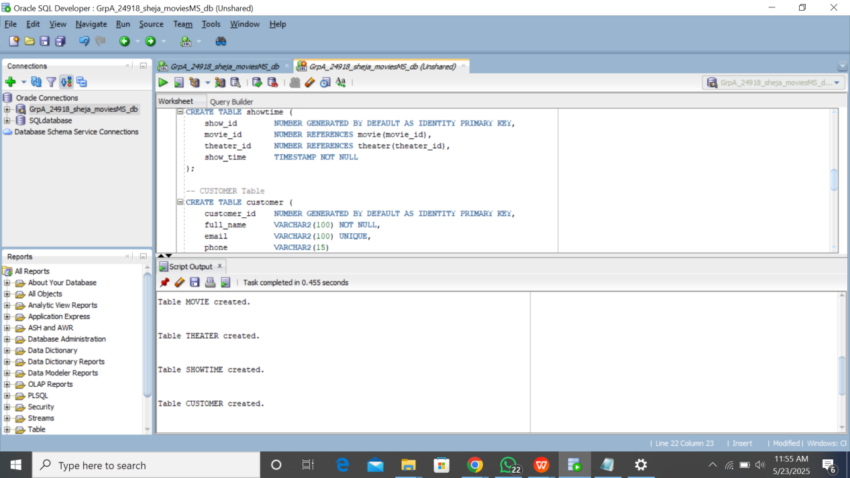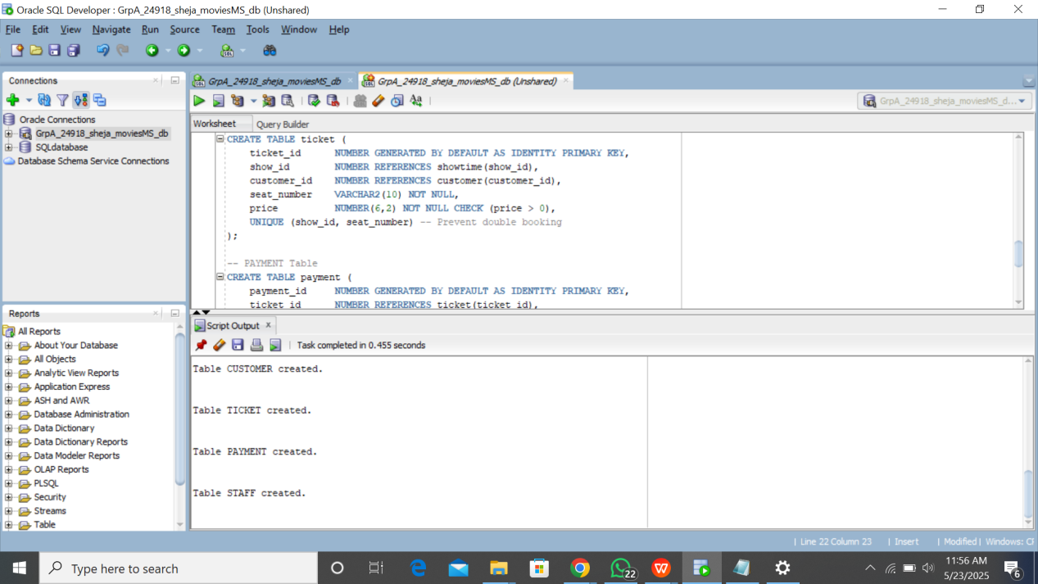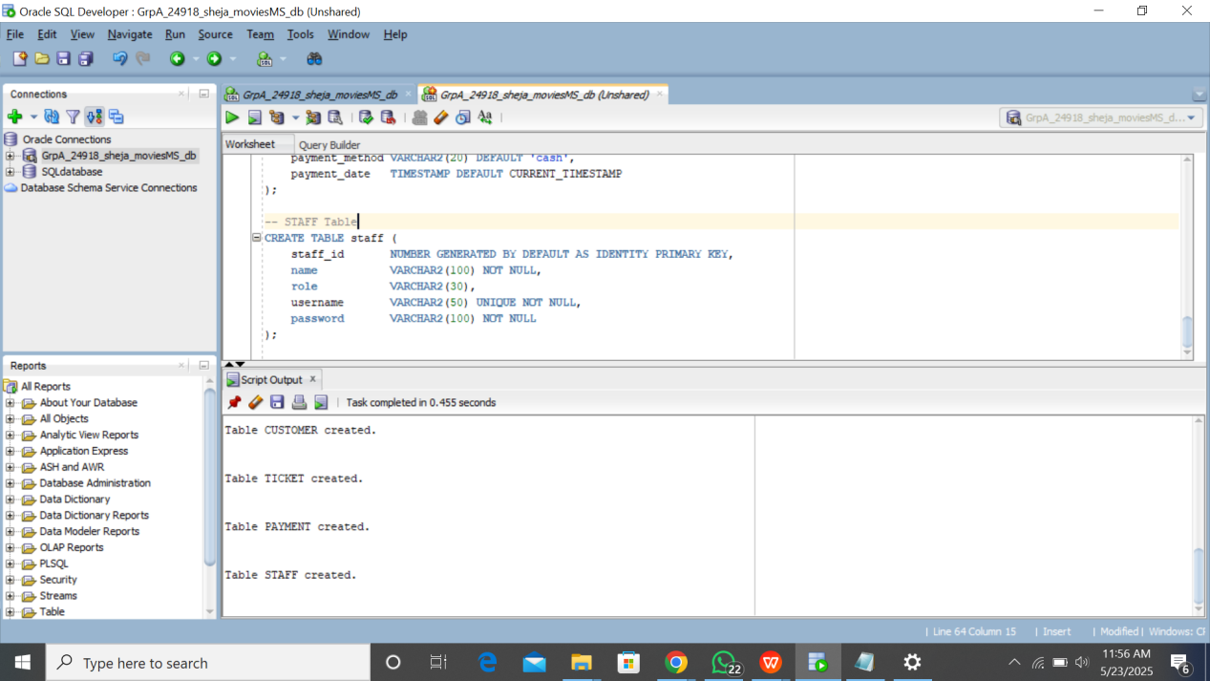

**DATA INSERTION**  
-- Insert sample movies

INSERT INTO movie (title, genre, duration, language, rating)

VALUES ('Inception', 'Sci-Fi', 148, 'English', 'PG-13');

INSERT INTO movie (title, genre, duration, language, rating)

VALUES ('The Matrix', 'Action', 136, 'English', 'R');

-- Insert sample theaters

INSERT INTO theater (name, location, total_seats)

VALUES ('Main Hall', 'Downtown', 120);

INSERT INTO theater (name, location, total_seats)

VALUES ('Elite Screen', 'Uptown', 80);

-- Insert sample customers

INSERT INTO customer (full_name, email, phone)

VALUES ('Alice Johnson', 'alice@gmail.com', '123456789');

INSERT INTO customer (full_name, email, phone)

VALUES ('Bob Smith', 'bob@example.com', '987654321');

-- Insert sample shows

INSERT INTO showtime (movie_id, theater_id, show_time)

VALUES (1, 1, TO_TIMESTAMP('2025-06-15 18:00', 'YYYY-MM-DD HH24:MI'));

INSERT INTO showtime (movie_id, theater_id, show_time)

VALUES (2, 2, TO_TIMESTAMP('2025-06-15 20:30', 'YYYY-MM-DD HH24:MI'));

-- Insert sample tickets

INSERT INTO ticket (show_id, customer_id, seat_number, price)

VALUES (1, 1, 'A10', 5000);

INSERT INTO ticket (show_id, customer_id, seat_number, price)

VALUES (2, 2, 'B5', 5500);

-- Insert sample payments

INSERT INTO payment (ticket_id, amount, payment_method)

VALUES (1, 5000, 'Mobile Money');

INSERT INTO payment (ticket_id, amount, payment_method)

VALUES (2, 5500, 'Cash');

**DATA INSERTED SUCCESSFULLY SCREENSHOTS  
